Patient Information
Name: _________________________________ Date: ___________ Date of Birth: ___________ Age: _____
Street Address: ____________________________________City, State, Zip: ___________________________
Phone: ____________________ Cell: ___________________ Email: _________________________________
Occupation: __________________________________________________________ Marital Status: S_ M_ D_
Emergency Contact
Name:____________________________ Relationship: _______________________Phone:________________

Primary Care Physician
Name: _______________________________ Phone: ___________________ Date of Next Visit: ___________

Who may we thank for your referral? __________________________________________________________

Informed Consent
I understand that Synergy Fitness for Her will maintain my privacy to the highest standards and may use or disclose my personal health information for the purposes of carrying out treatment, obtaining payment, evaluating the quality of services provided, and any administrative operations related to treatment or payment.

I do hereby agree and give consent for Synergy Fitness for Her to provide care and treatment that is considered necessary and proper in the diagnosing or treating of my physical condition.

I understand that I retain the right to revoke this consent by notifying the practice in writing at any time.

Patient/Parent/Guardian Signature__________________________________________

Patient/Parent/Guardian Print Name ____________________________________ Date_________________

What is the primary problem that brings you in today?
__________________________________________________________________________________________
__________________________________________________________________________________________
When did this begin? ________________________________________________________________________
Have you had this problem before? Yes _____ No ______
If so, how long did it take to resolve? ___________________________________________________________
Secondary concern/problem? _________________________________________________________________
Type of Pain
Sharp/Burning/ Aching/ Pins & Needles/ Throbbing/ Numbness/ Other
Rate your average pain on a 0 to 10 scale (0=no pain, 10=worst imaginable pain)
Current____ Best in 24 hours_____ Worst in 24 hours _____
Symptoms: Come and go _____ Are constant _______ Are constant but change with activity ______
Please mark on the body where your symptoms are located
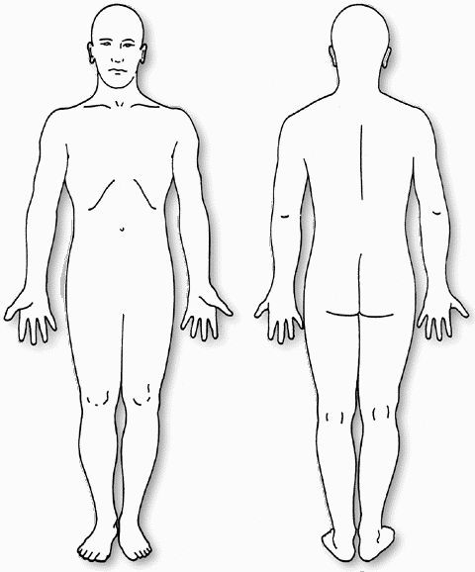
When are your symptoms the worst ___________________________ Best? ___________________________
My symptoms are currently ____ getting better ___ getting worse ___ staying about the same
What aggravates your symptoms? ___________________________________________________________
What relieves your symptoms? ______________________________________________________________
How are you currently able to sleep at night due to your symptoms? ___ No problem
___ Difficulty falling asleep ___ Awakened by pain ___ Sleep only with medication
Any treatment received so far for these symptoms? _______________________________________________
Any special tests? __________________________________________________________________________

Identify important activities that you are unable to do or are having difficulty with as a result of your problem/symptoms. Rate your difficulty based on a 0 to 10 scale with 0= “unable to perform” and 10= “no difficulty”
1. _____________________________________________________0 1 2 3 4 5 6 7 8 9 10
2. _____________________________________________________0 1 2 3 4 5 6 7 8 9 10
3. _____________________________________________________0 1 2 3 4 5 6 7 8 9 10

